Urban Cafe has a perfect concept for an immersive 3D website because your menu changes daily, you have signature "Urban Legends" dishes, specialty drinks, and a strong visual identity. Looking at the food posts you've shared, I would design it as a premium, modern, interactive experience similar to high-end restaurant websites.

Homepage Concept

Hero Section (3D)
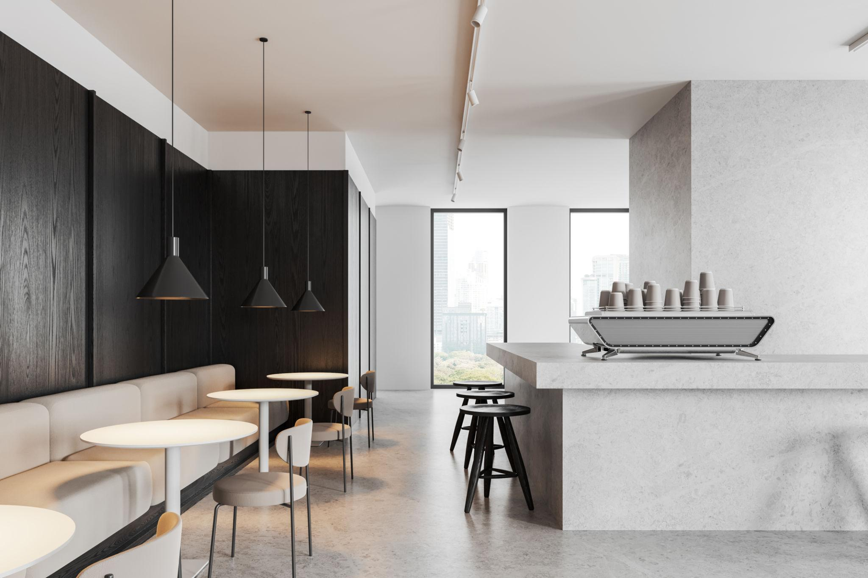
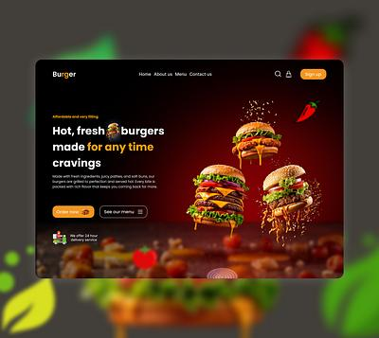
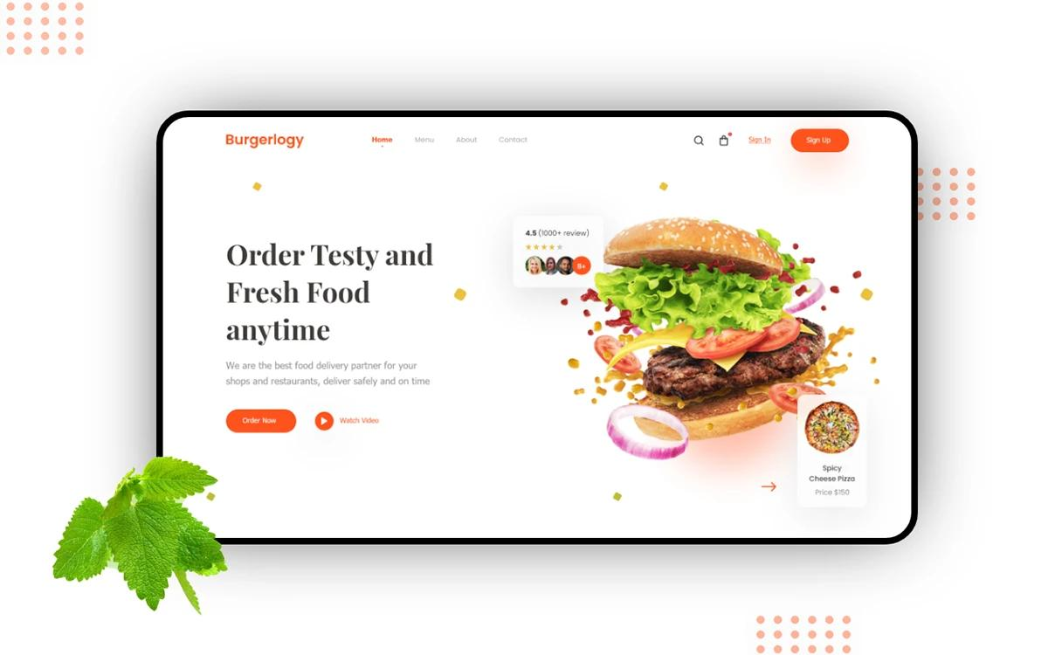
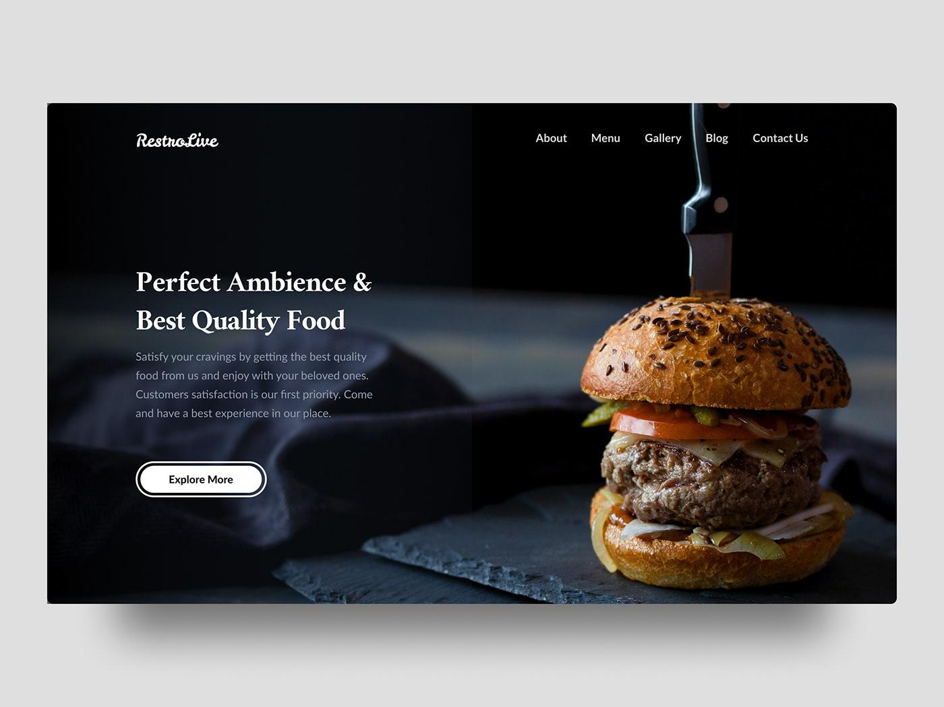
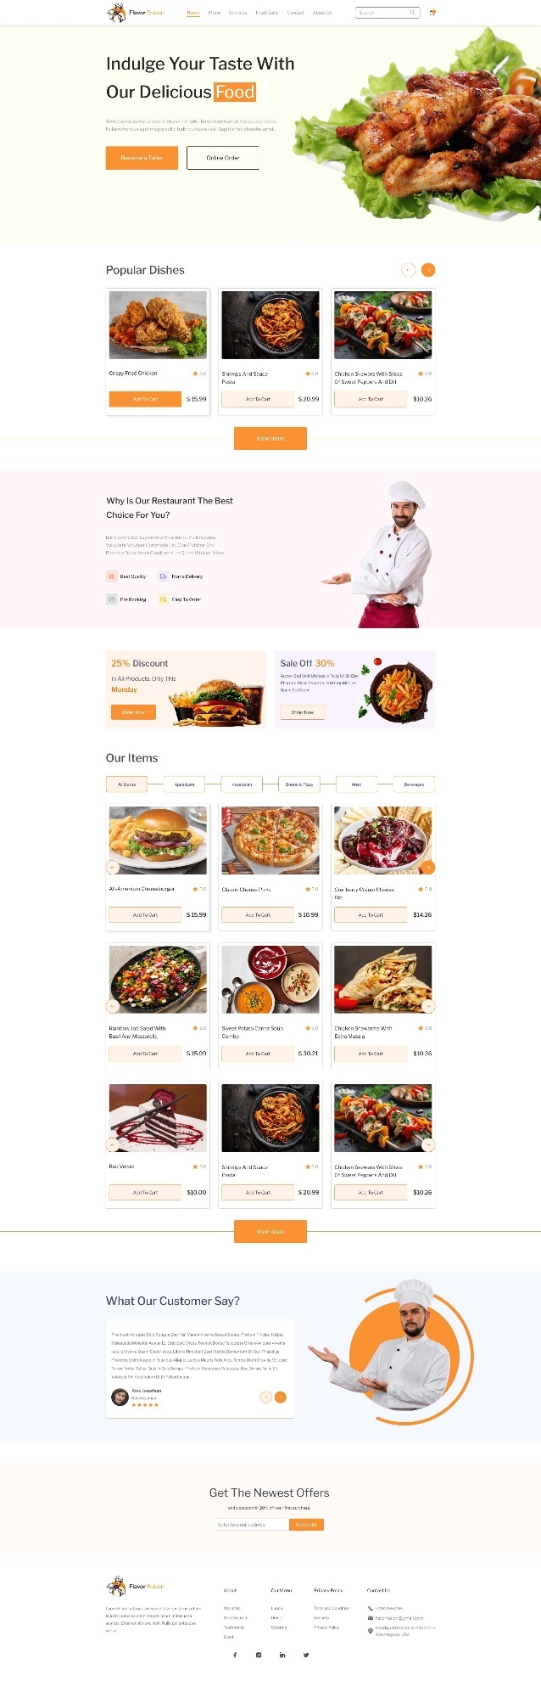
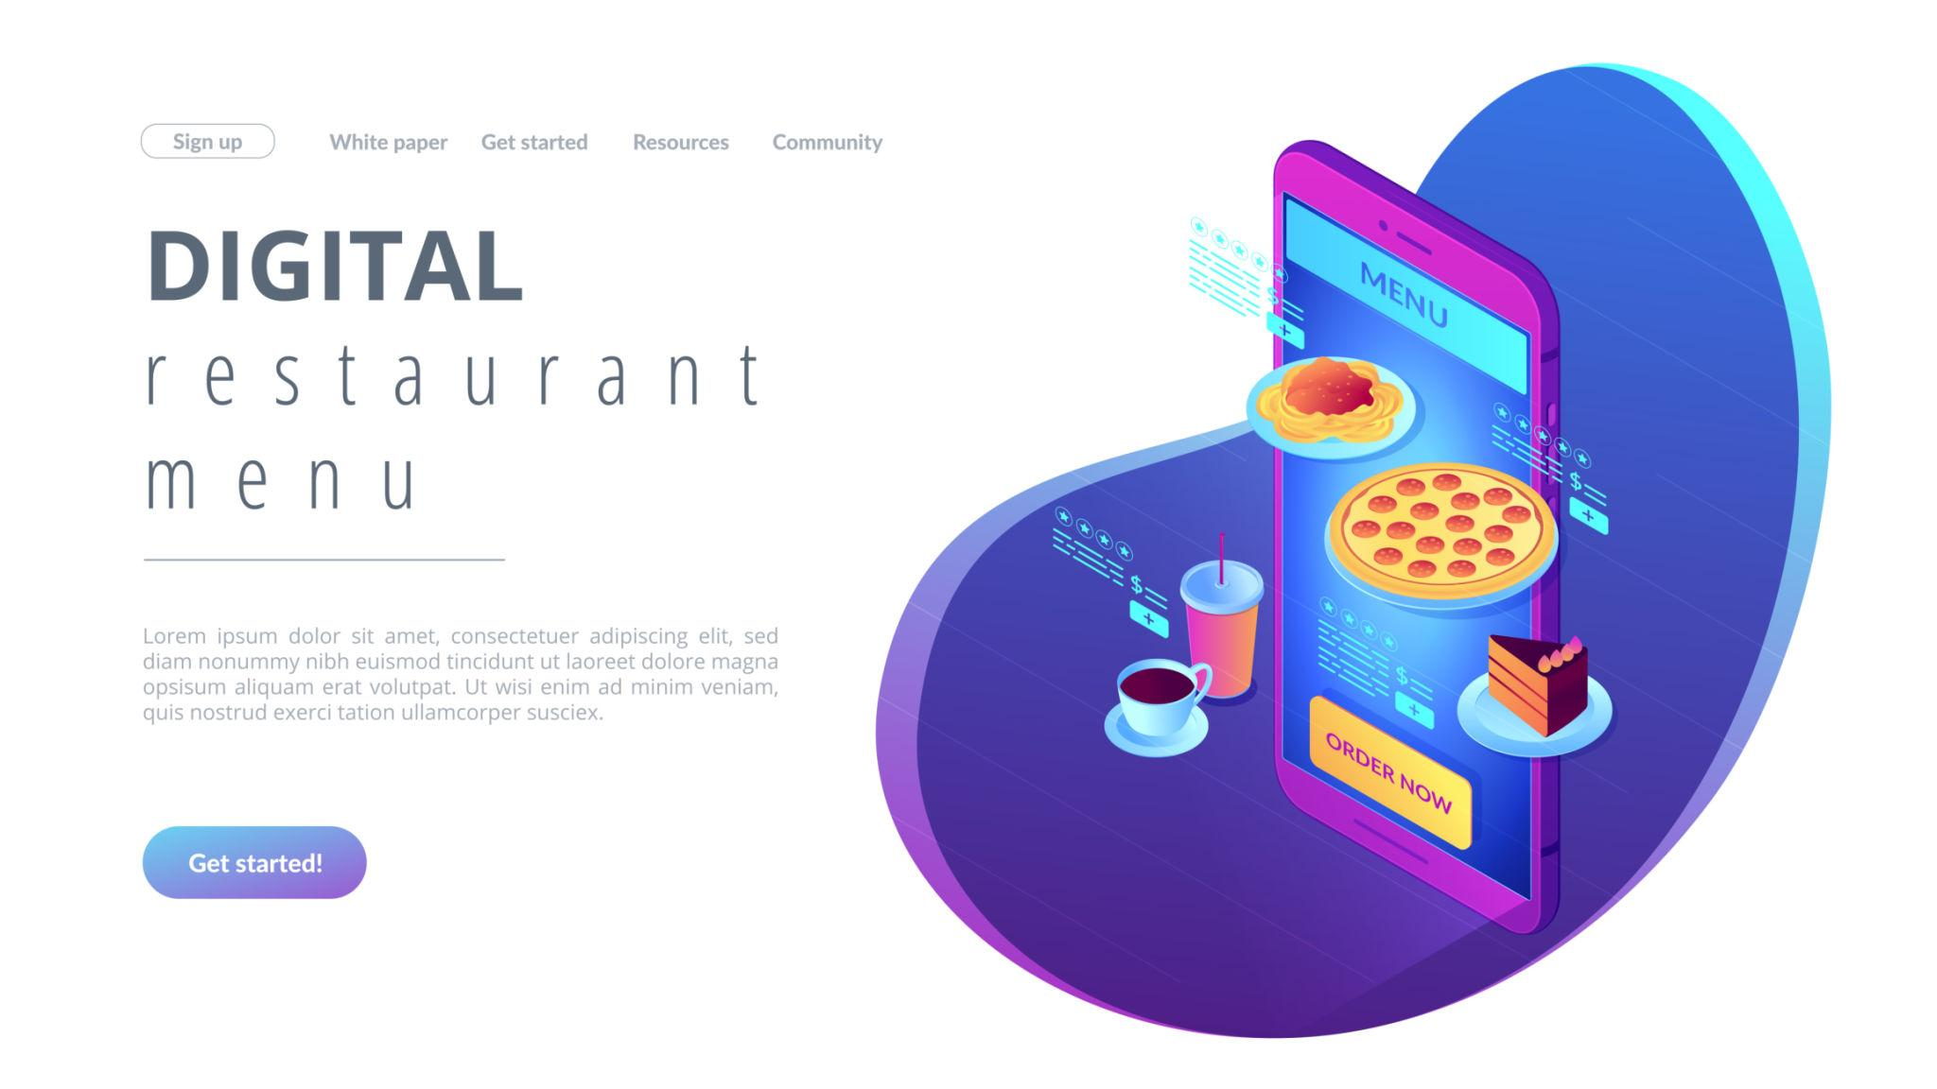
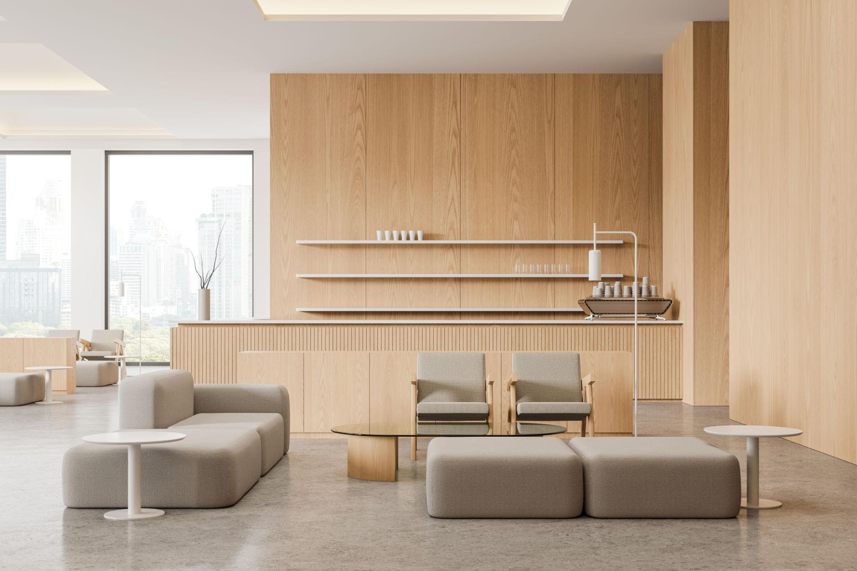
When visitors enter:
- Camera slowly moves through Urban Cafe
- Fresh coffee steam rises from cups
- Signature dishes rotate slightly in 3D
- Warm lighting
- Ambient café sounds
Headline:
URBAN CAFE
Freshly Prepared. Made Today.
Button:
Explore Today's Menu

Daily Specials Section
This should be the star feature.

Interactive 3D Menu Cards
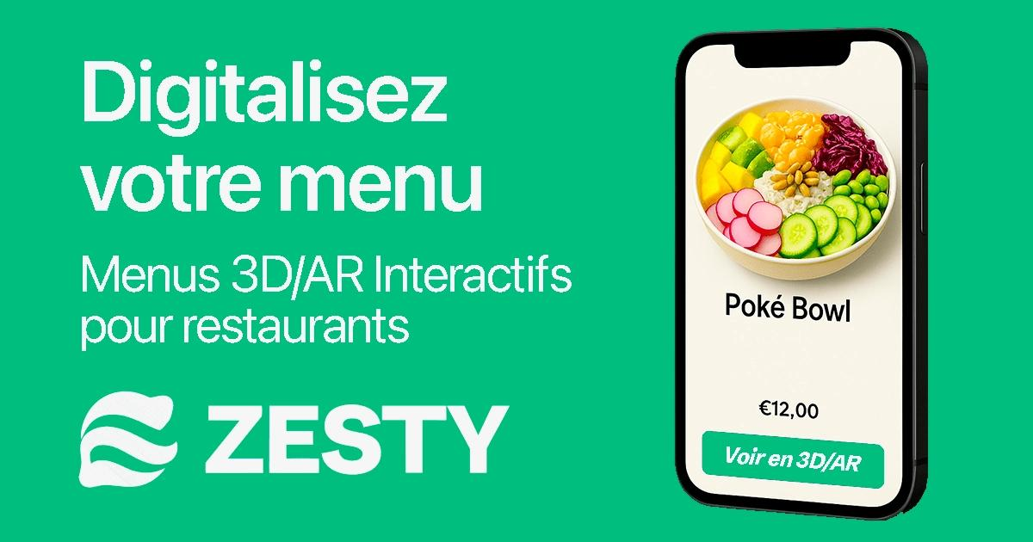
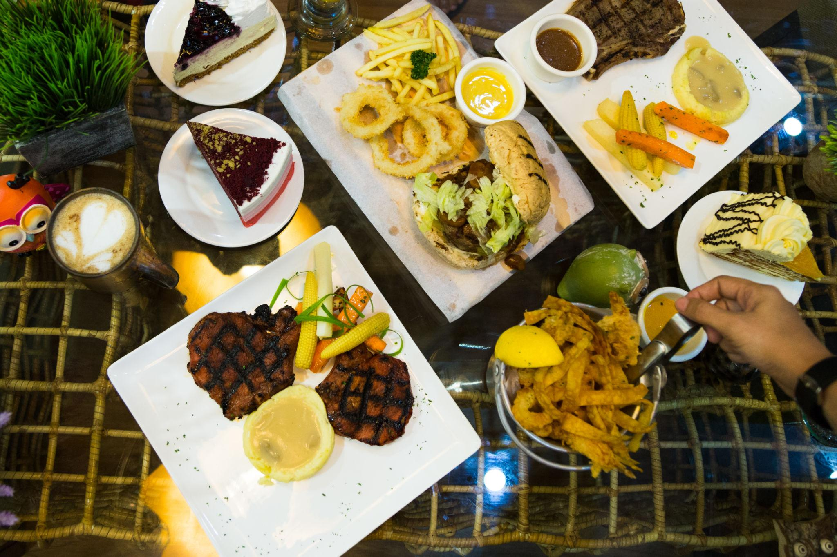
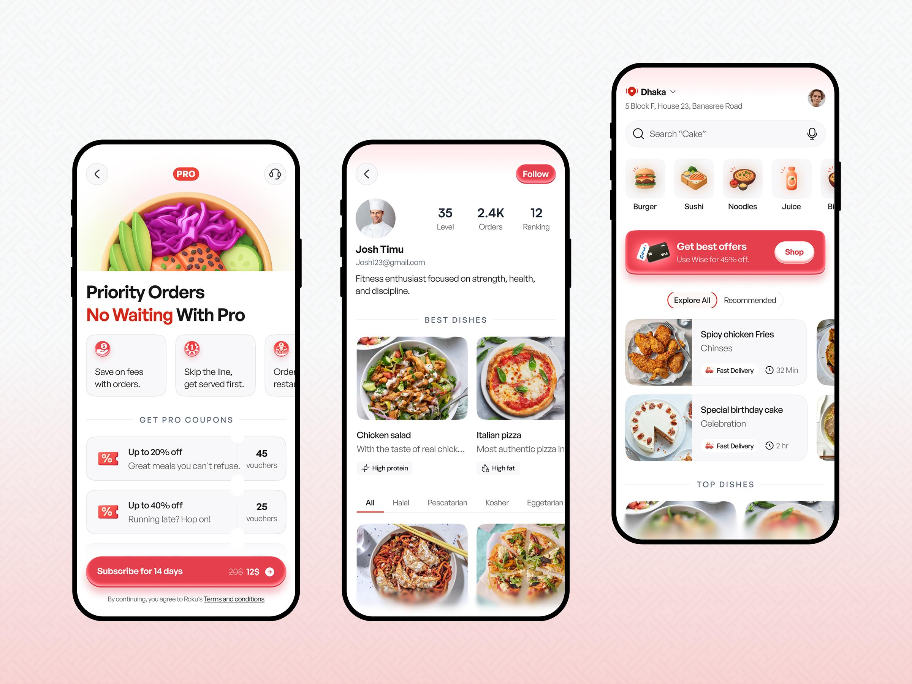
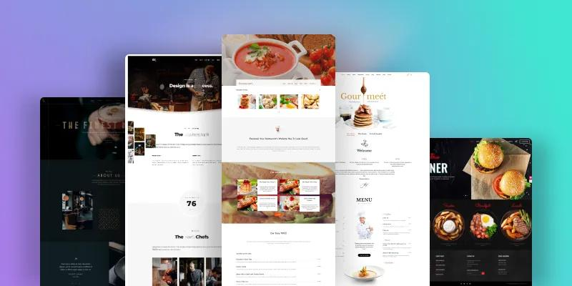
Each card:
- Tilts on hover
- Food rises slightly
- Ingredients orbit around dish
- Steam animation for hot food
Examples:
- Goat Curry
- Nashville Chicken Burger
- Pad Thai
- Seafood Rice
- Steak Burrito Bowl
When clicked:
3D plate expands full screen.

Urban Legends Section
Your permanent menu deserves a dedicated area.

Hall of Fame
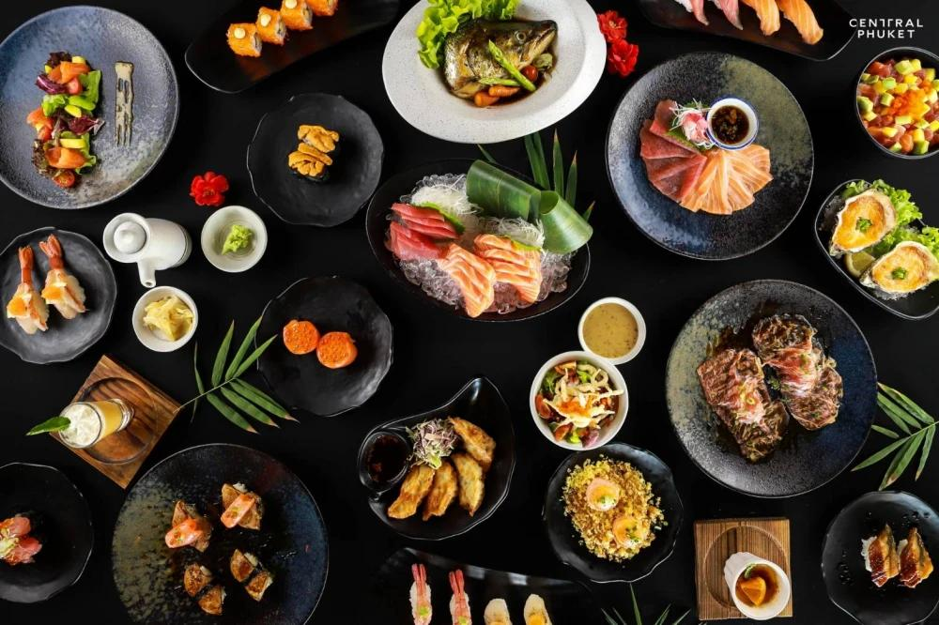
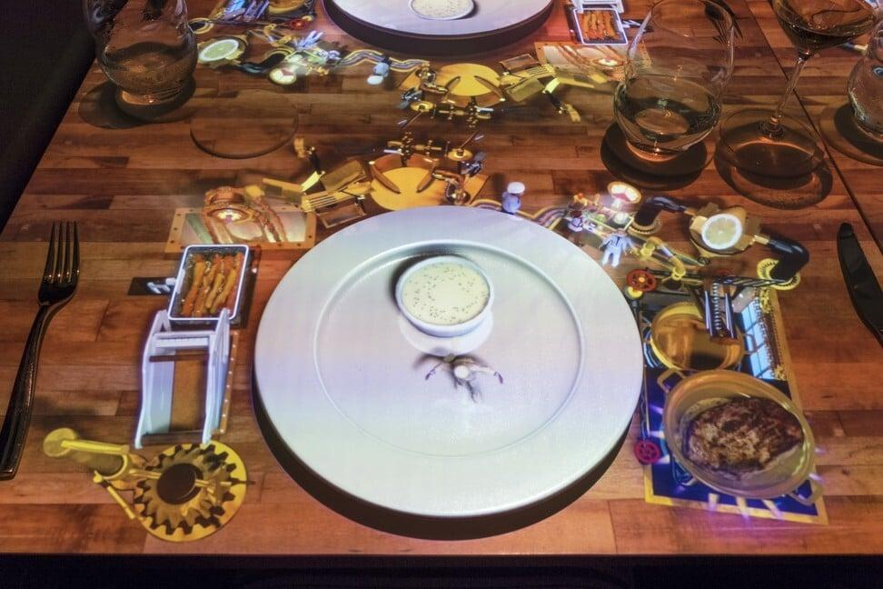
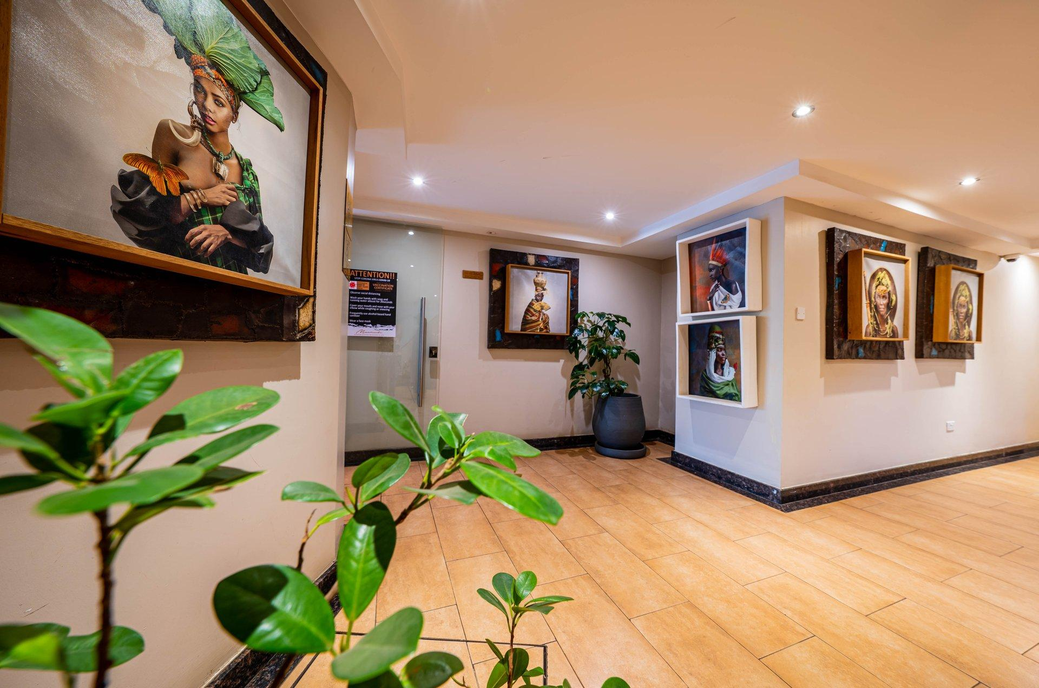
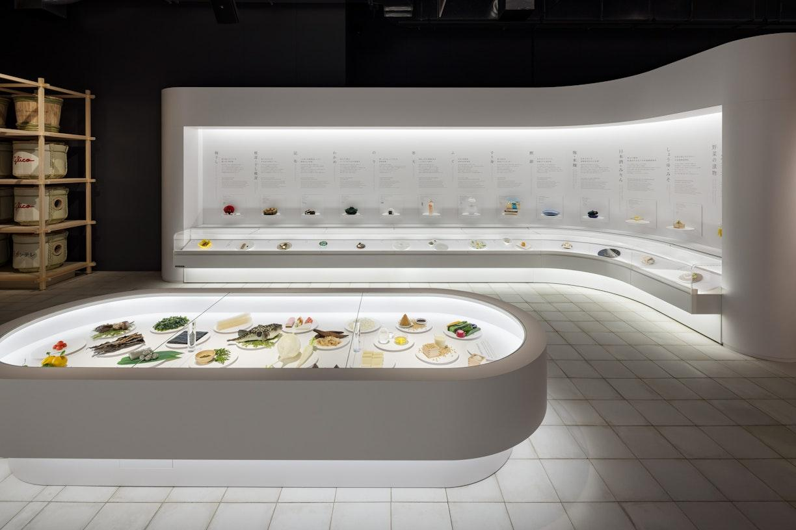
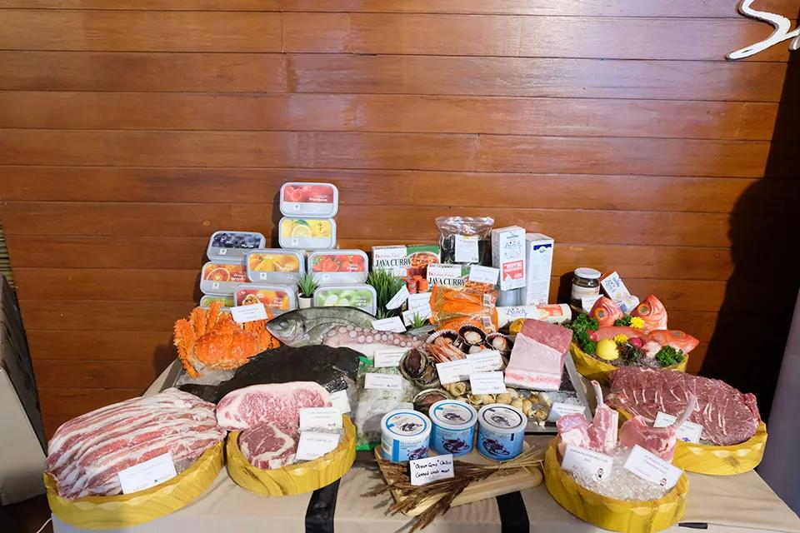
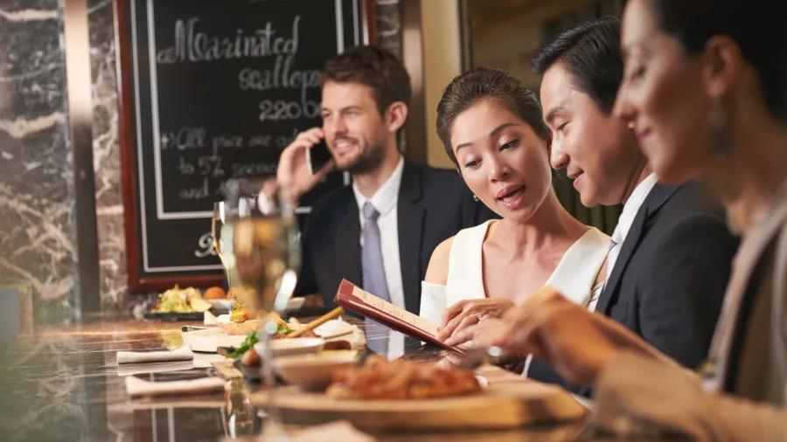
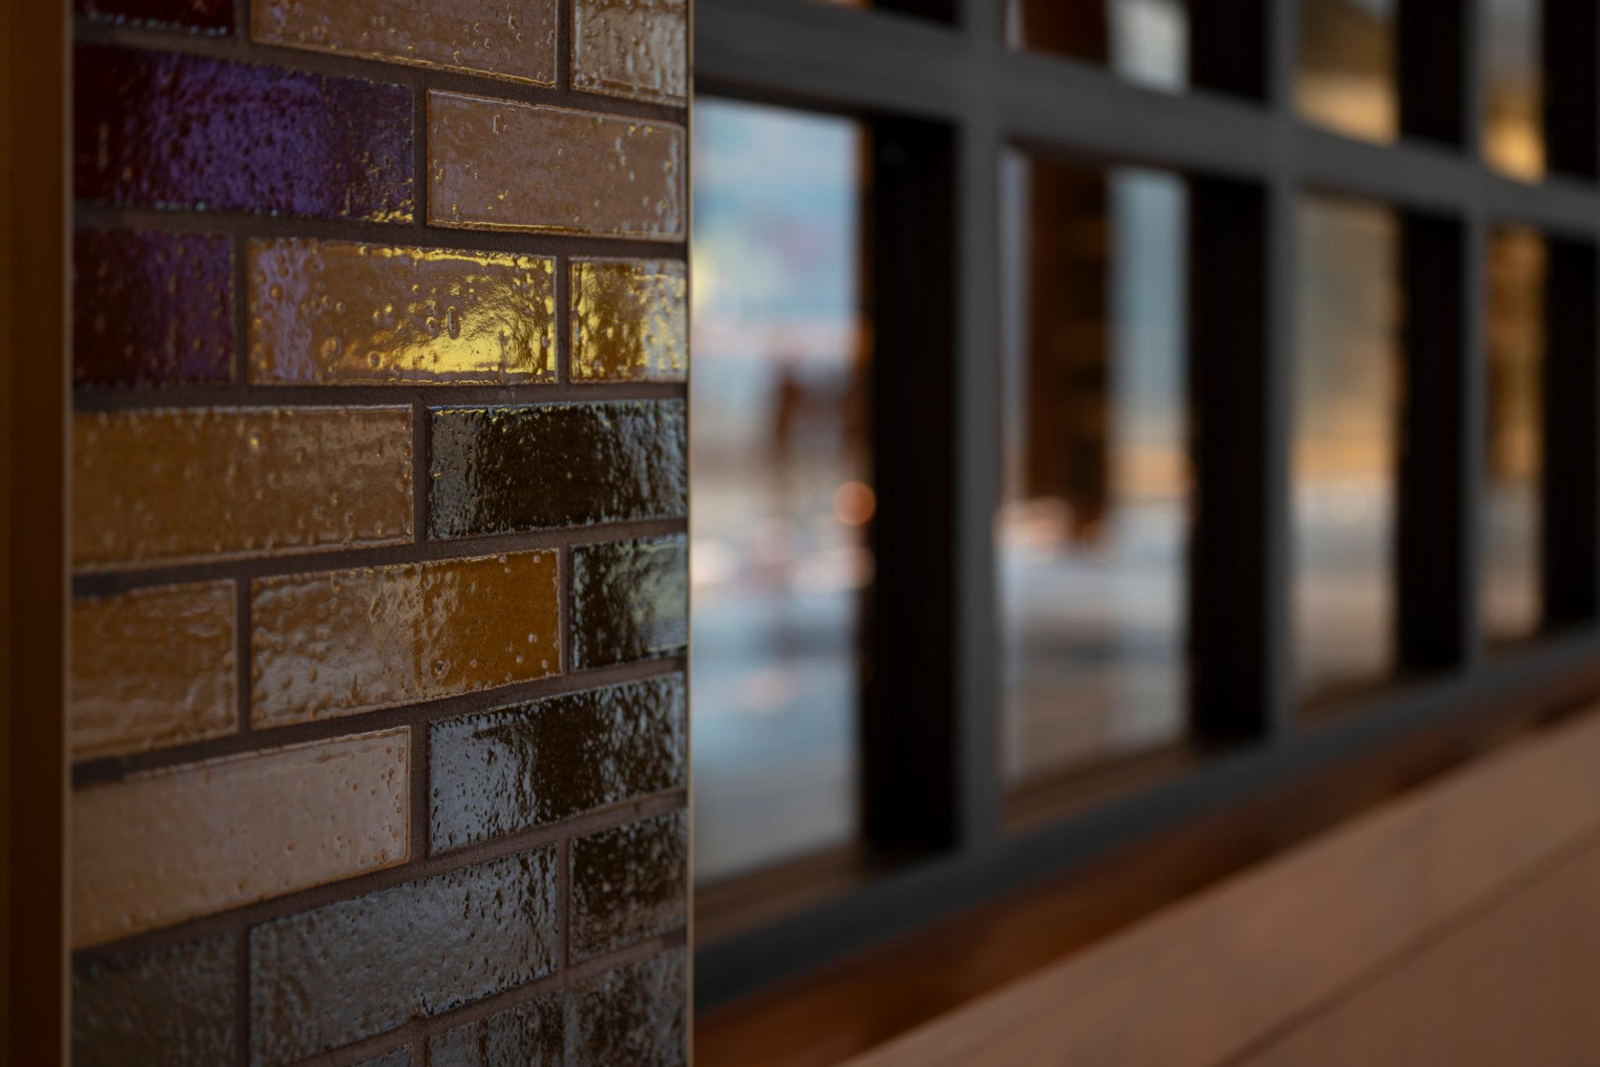
Think of this like:
"Urban Legends"
Signature dishes displayed on illuminated pedestals.
Examples:
- Cinnamon Rolls
- Cheesecake Collection
- Fish & Chips
- Urban Burgers
- Burrito Bowls
Hover effect:
- Plate slowly rotates
- Description appears
- Customer favorites badge glows

Drinks Experience

Floating Drinks Gallery
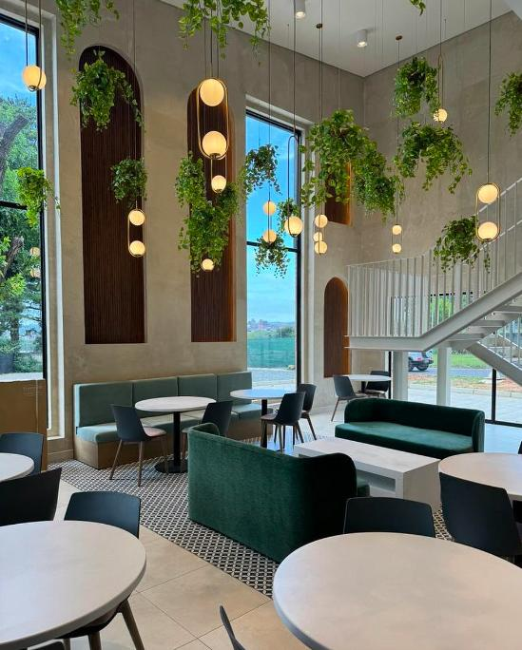
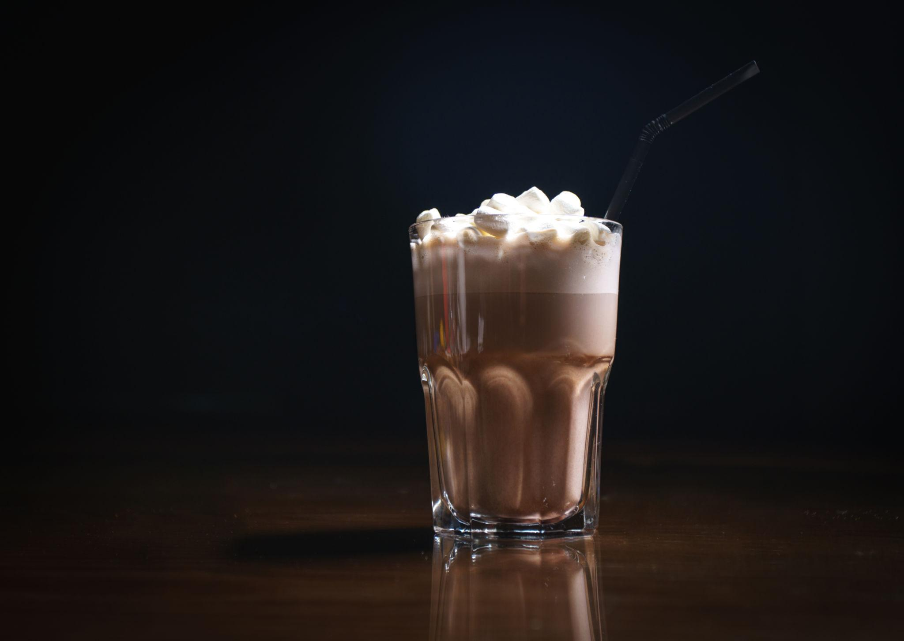
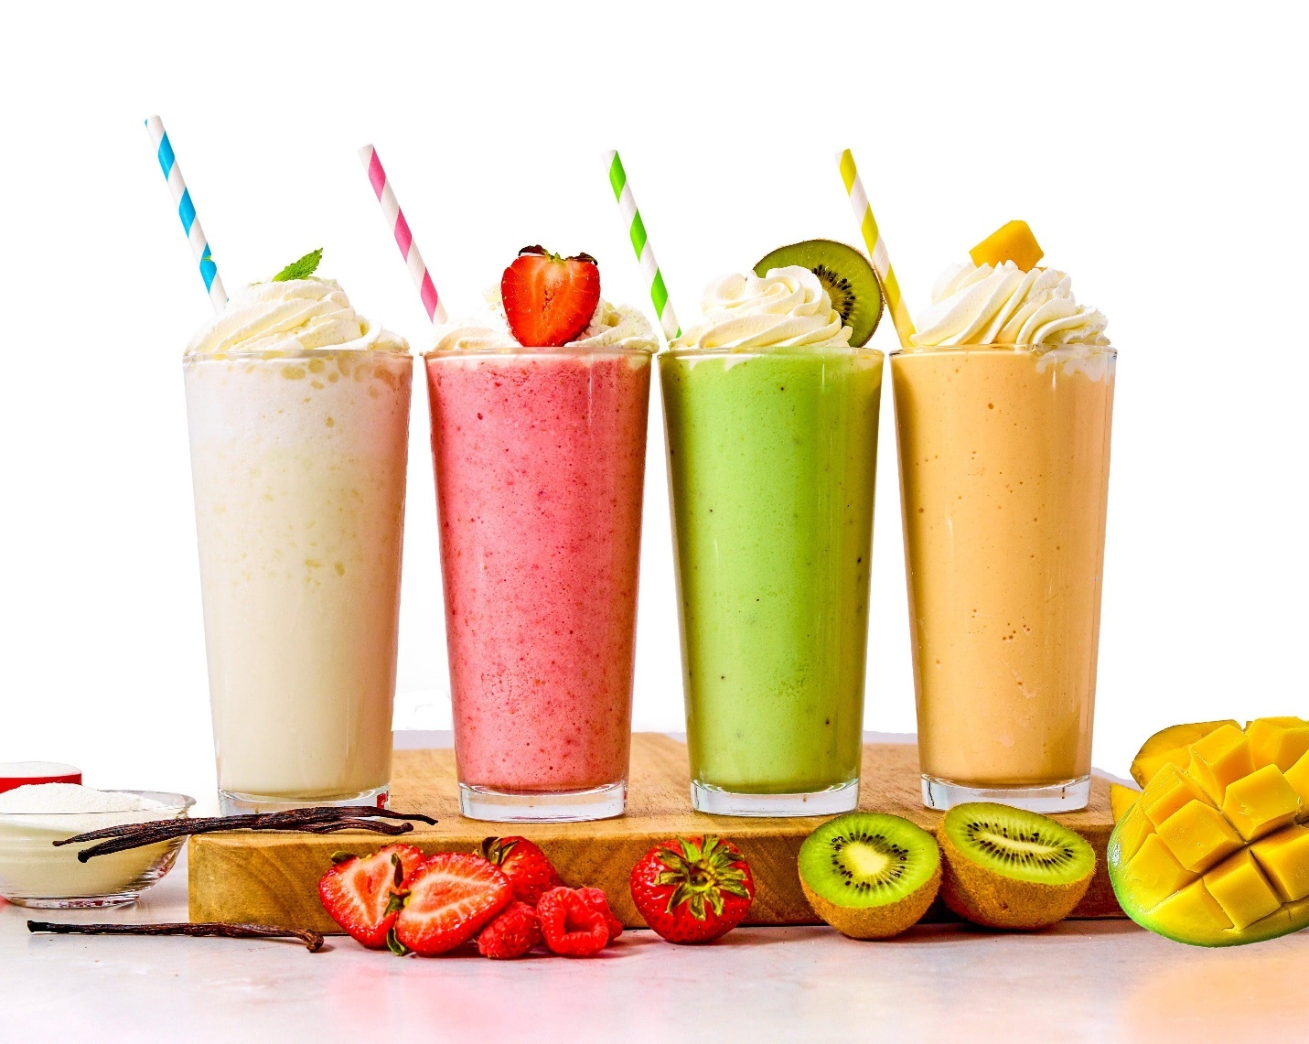
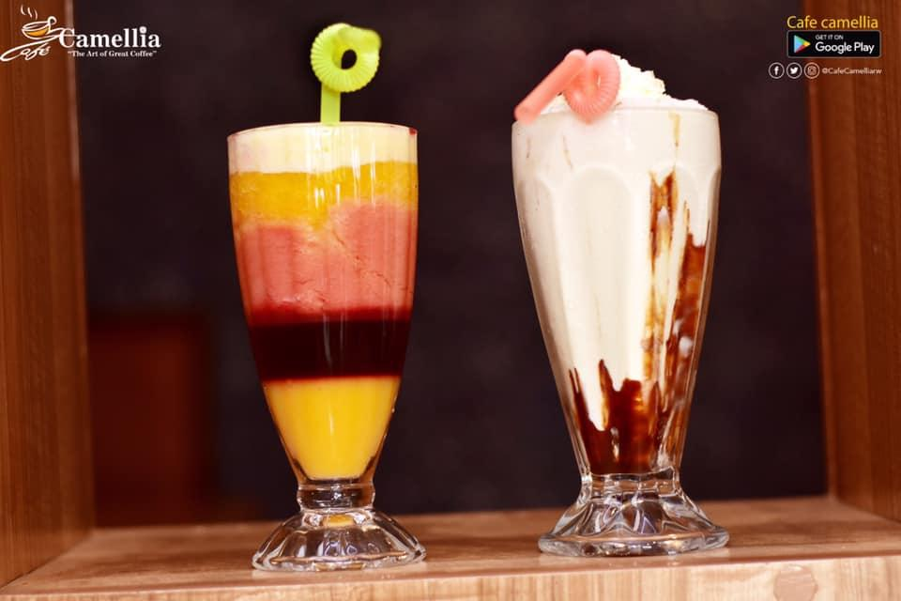
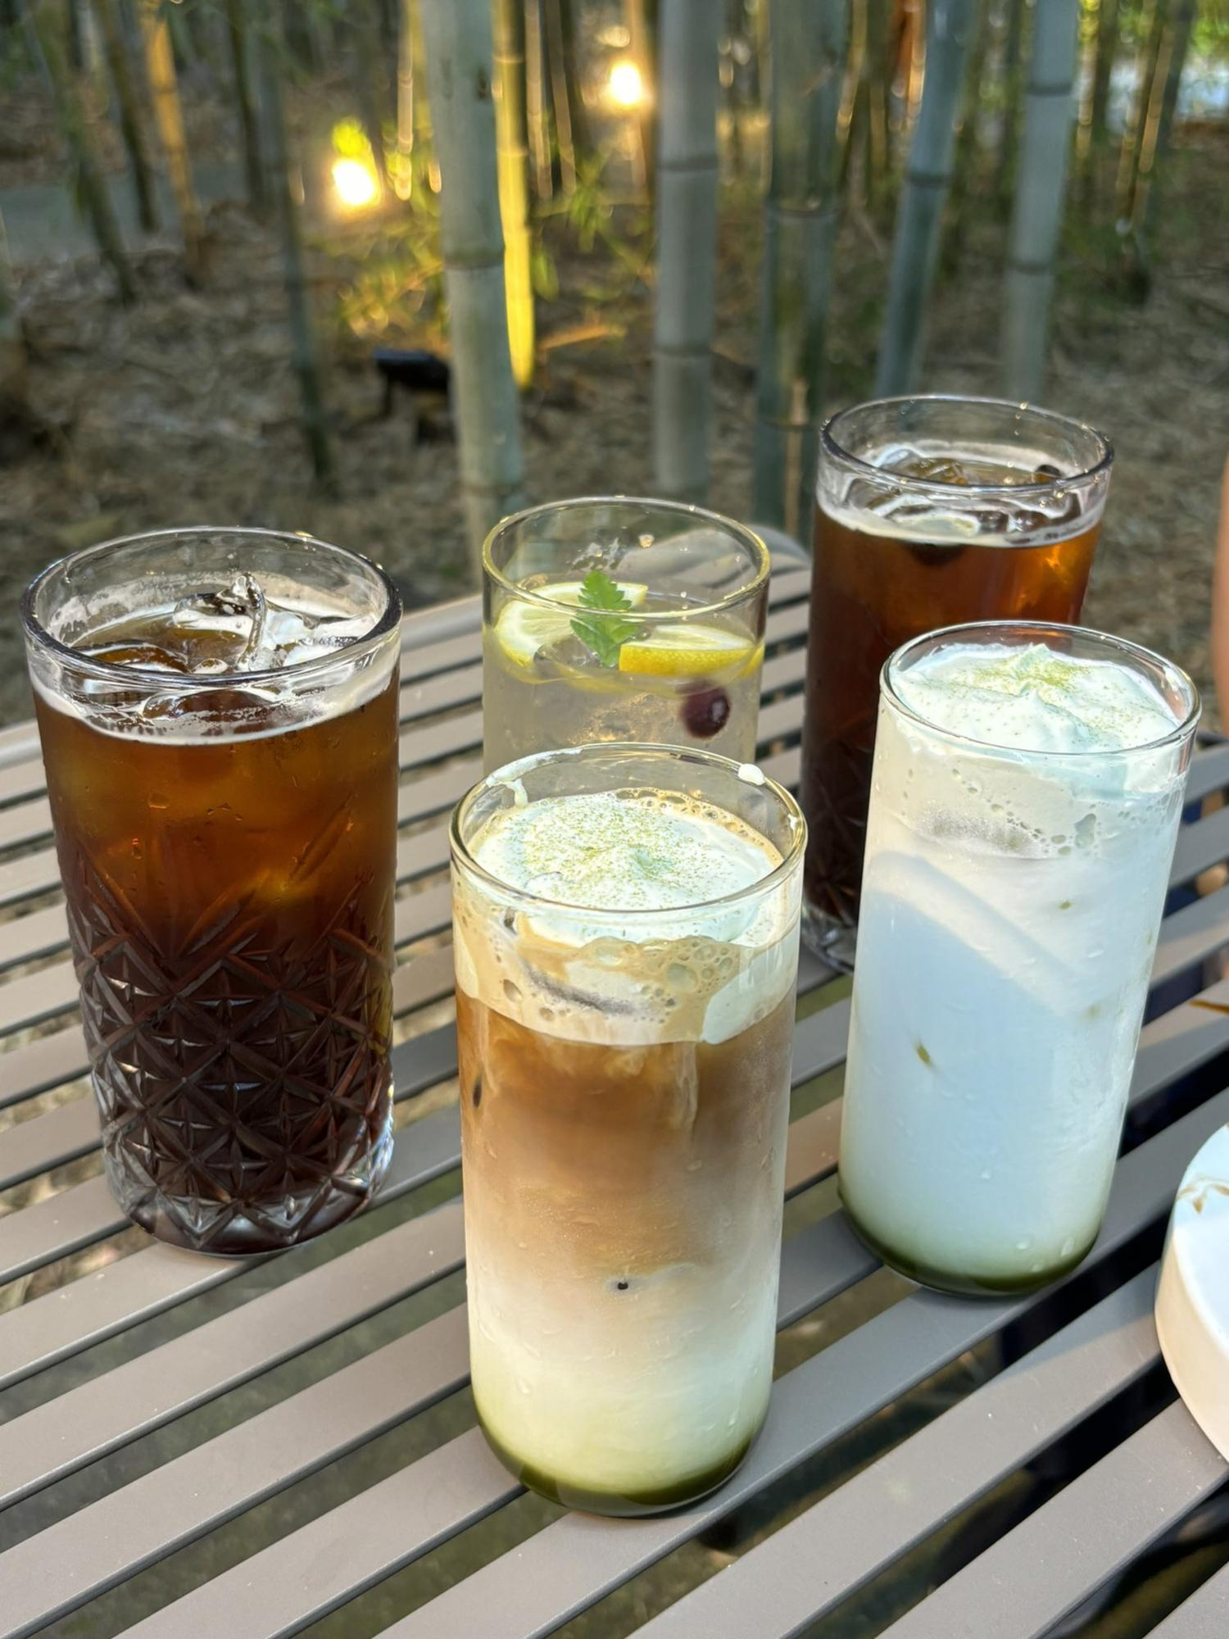
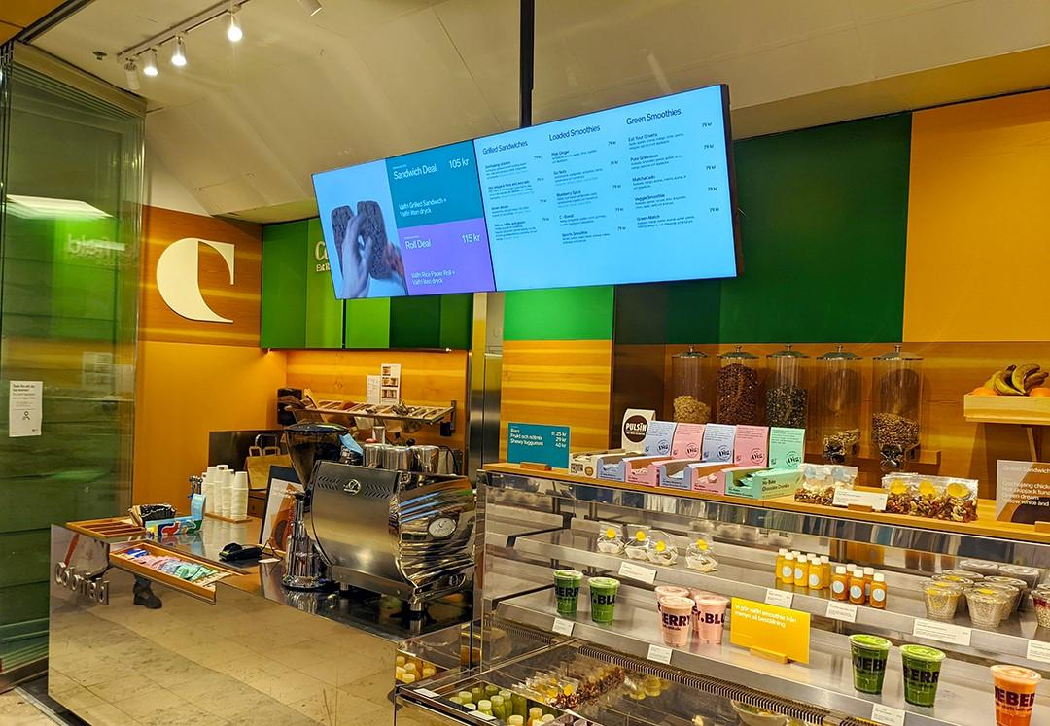
Categories:
☕ Coffee
- Espresso
- Cappuccino
- Latte
- Flat White
🥤 Milkshakes
🍓 Smoothies
🧋 Frappes
🍋 Iced Teas
When hovering:
- Ice cubes float
- Condensation animation
- Coffee steam effect

Vegan & Vegetarian Garden
Instead of a normal menu section:
Create a virtual garden.
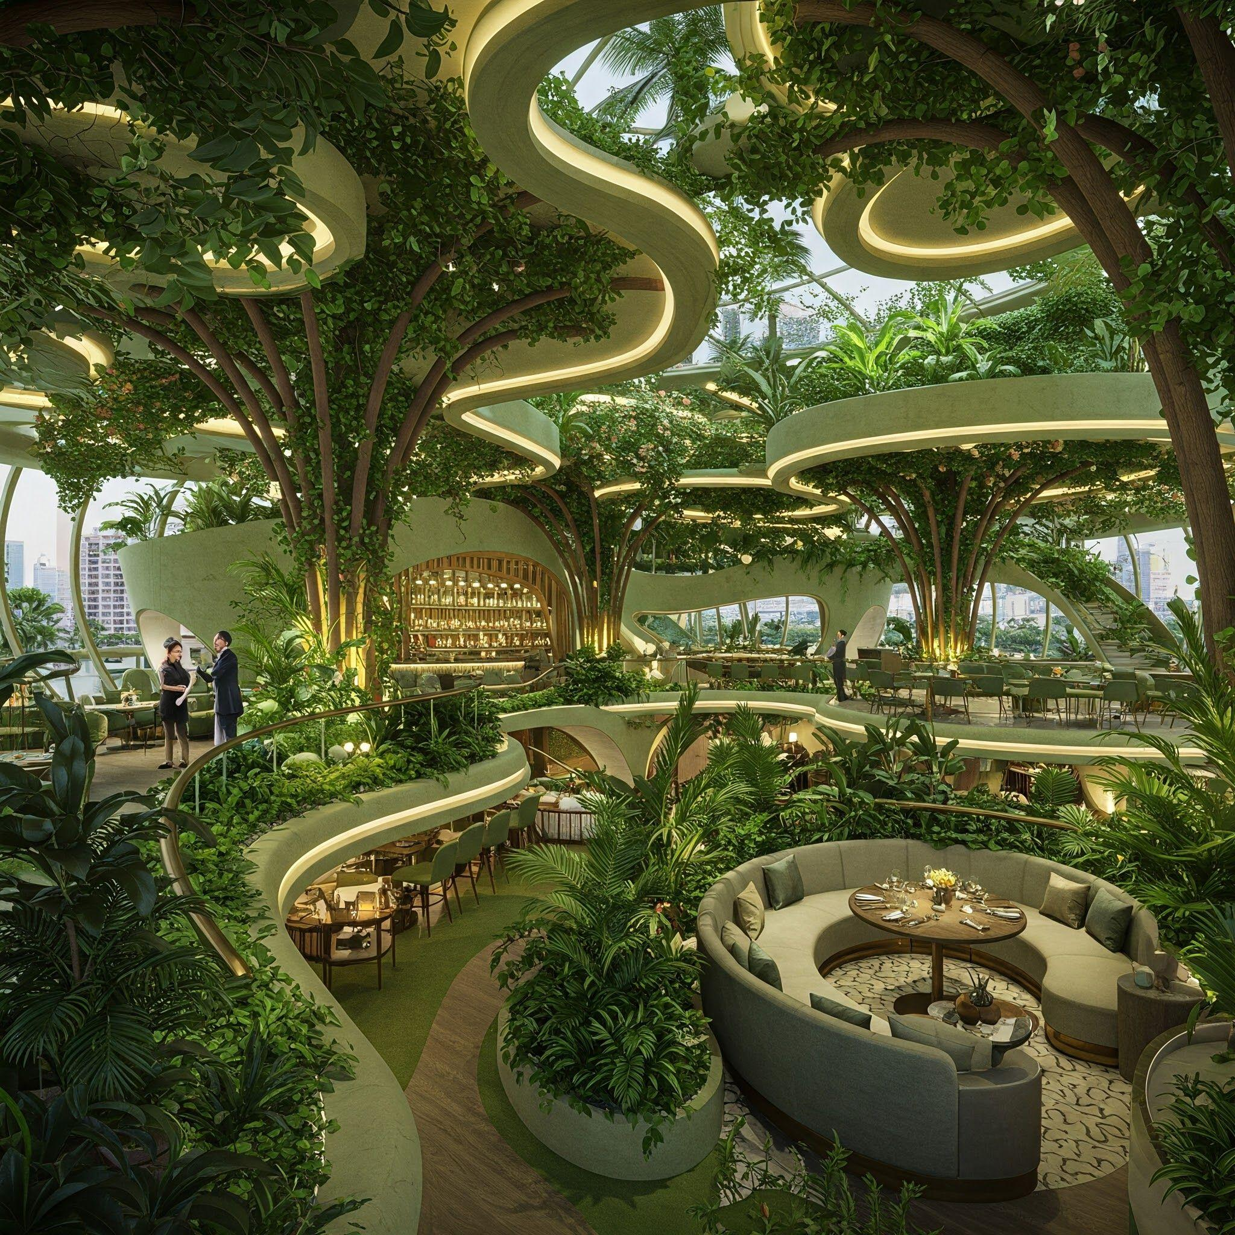
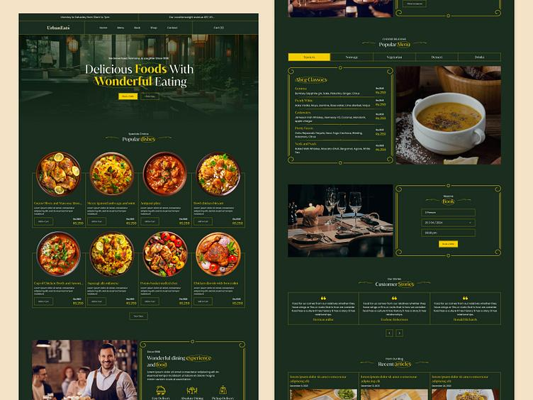
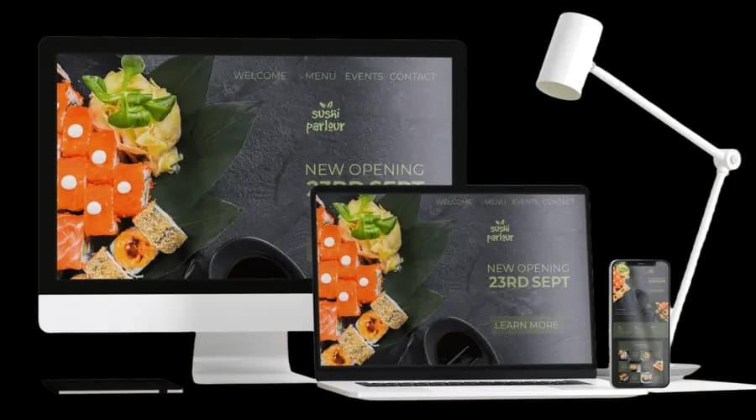
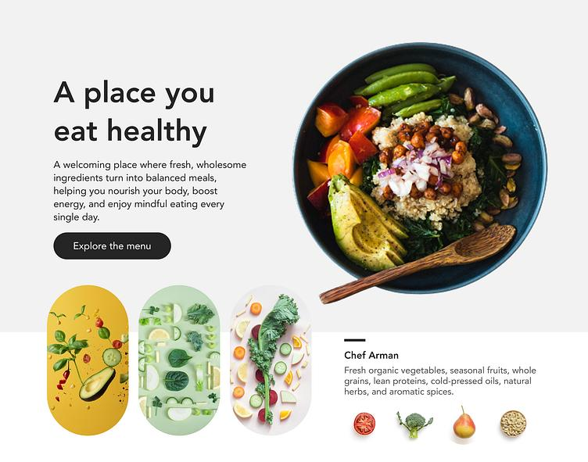
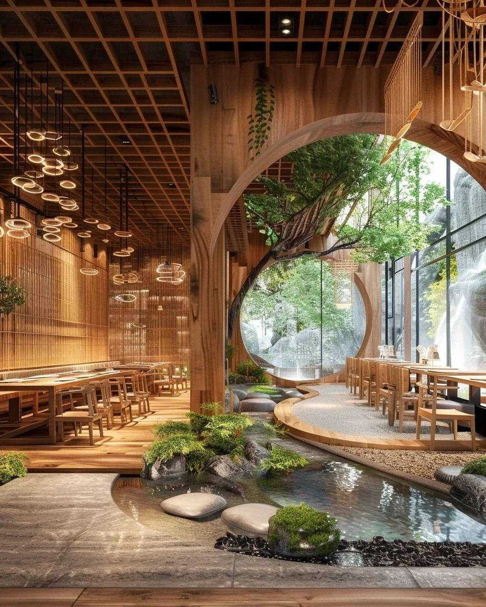
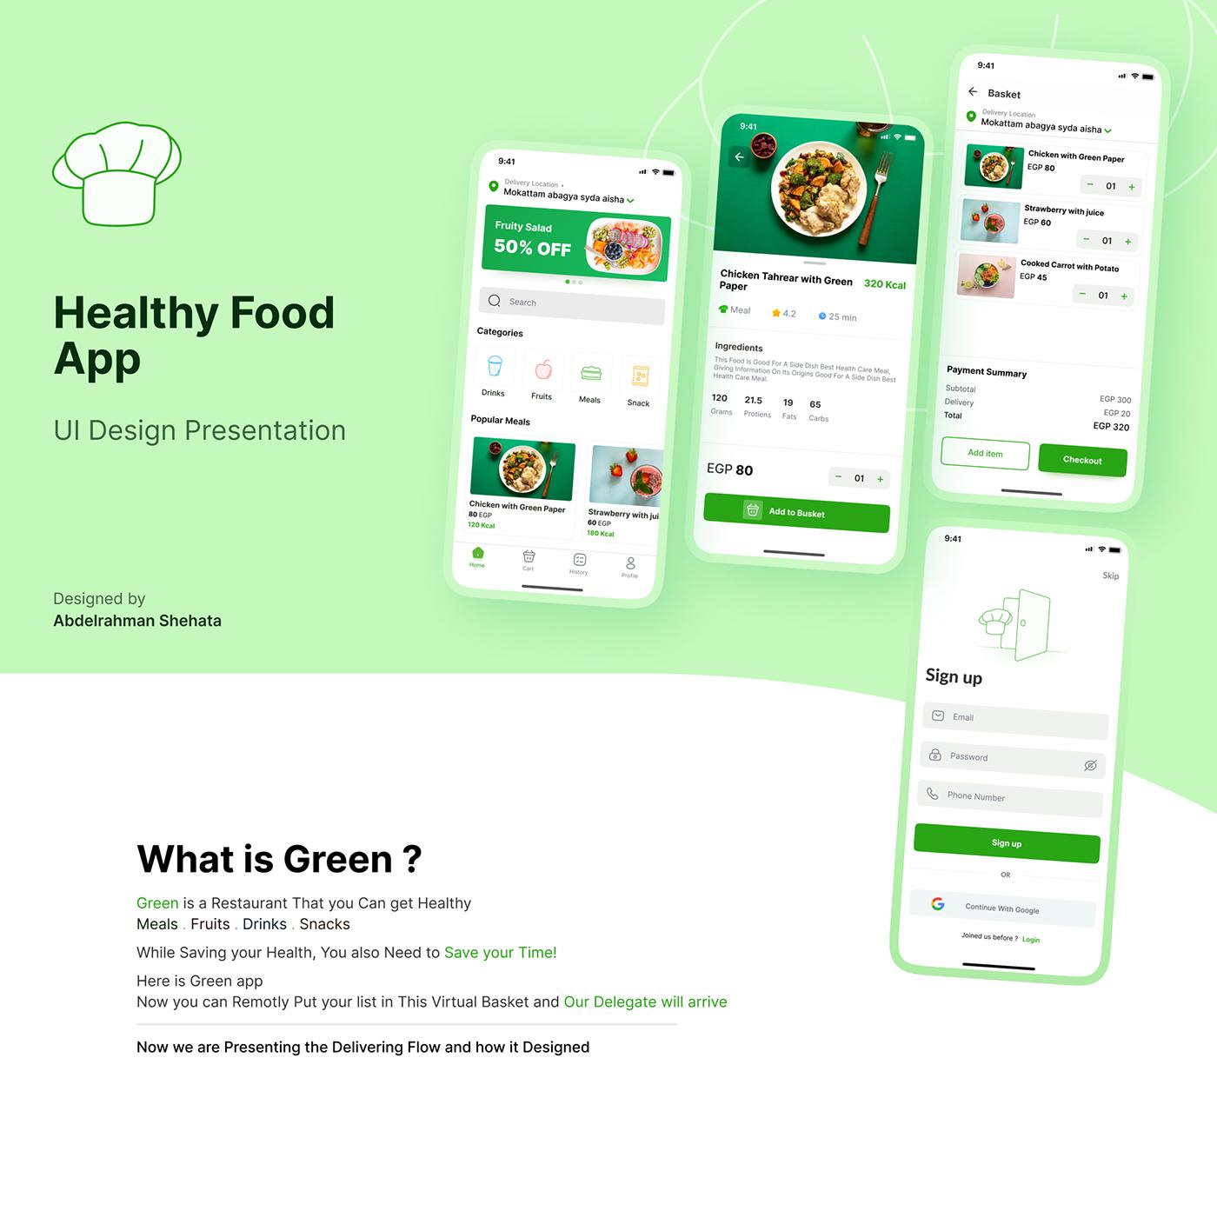
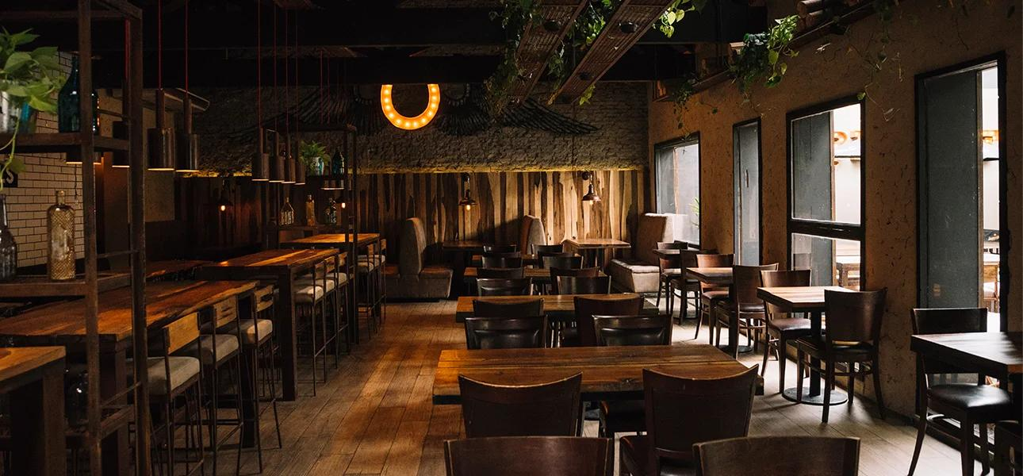
Each dish grows from:
- Herbs
- Vegetables
- Leaves
Animations:
- Fresh herbs sway
- Ingredients appear around plate

3D Table Reservation Area
Visitors can:
- Walk through the cafe
- Choose a table
- View seating availability
Like entering Urban Cafe virtually.

Dessert Showcase
Your cheesecakes and cinnamon rolls deserve special treatment.
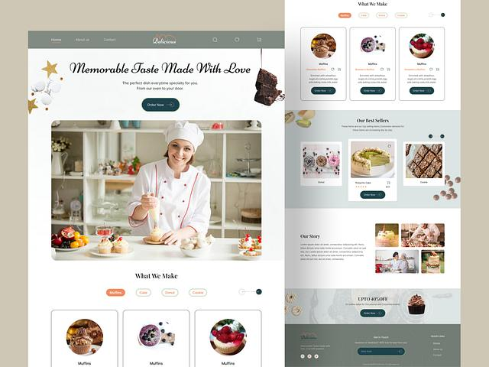
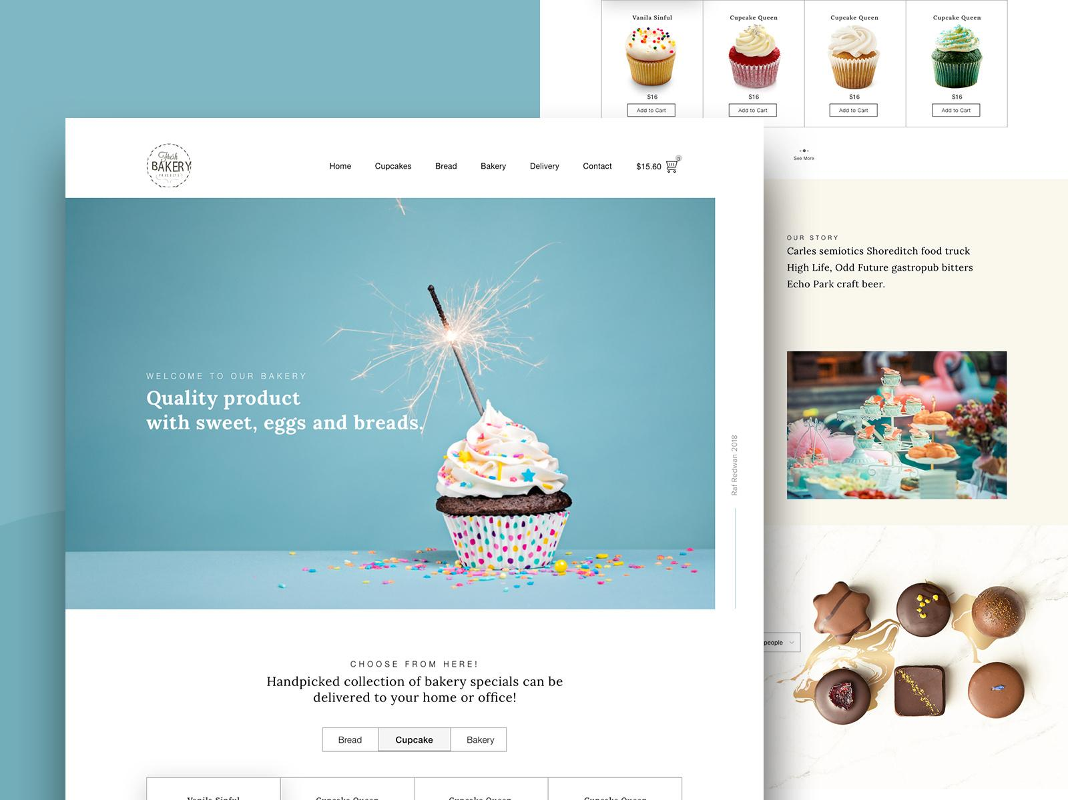
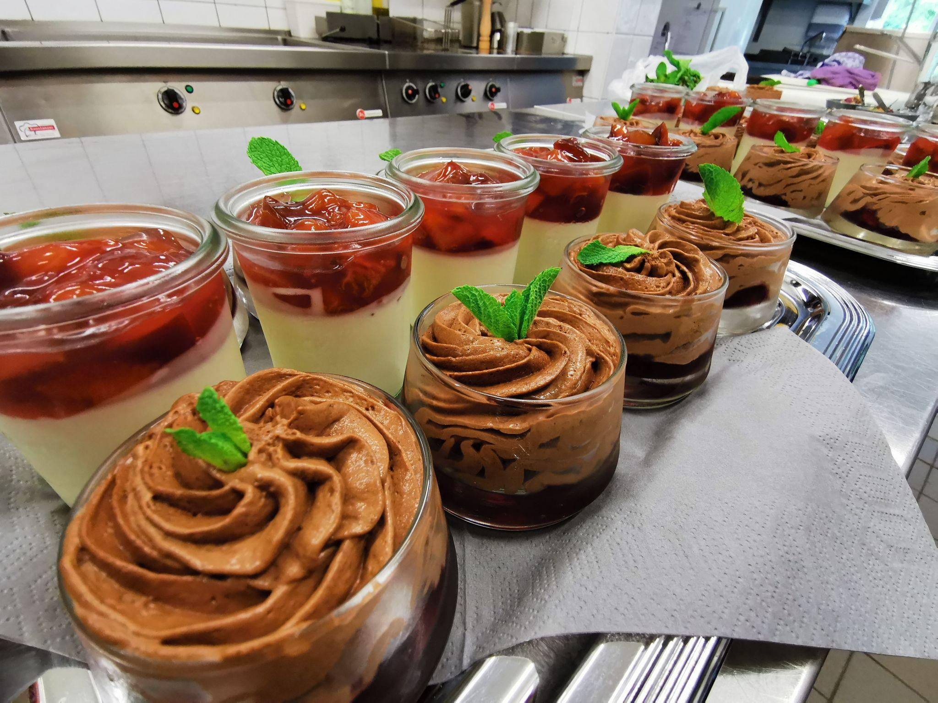
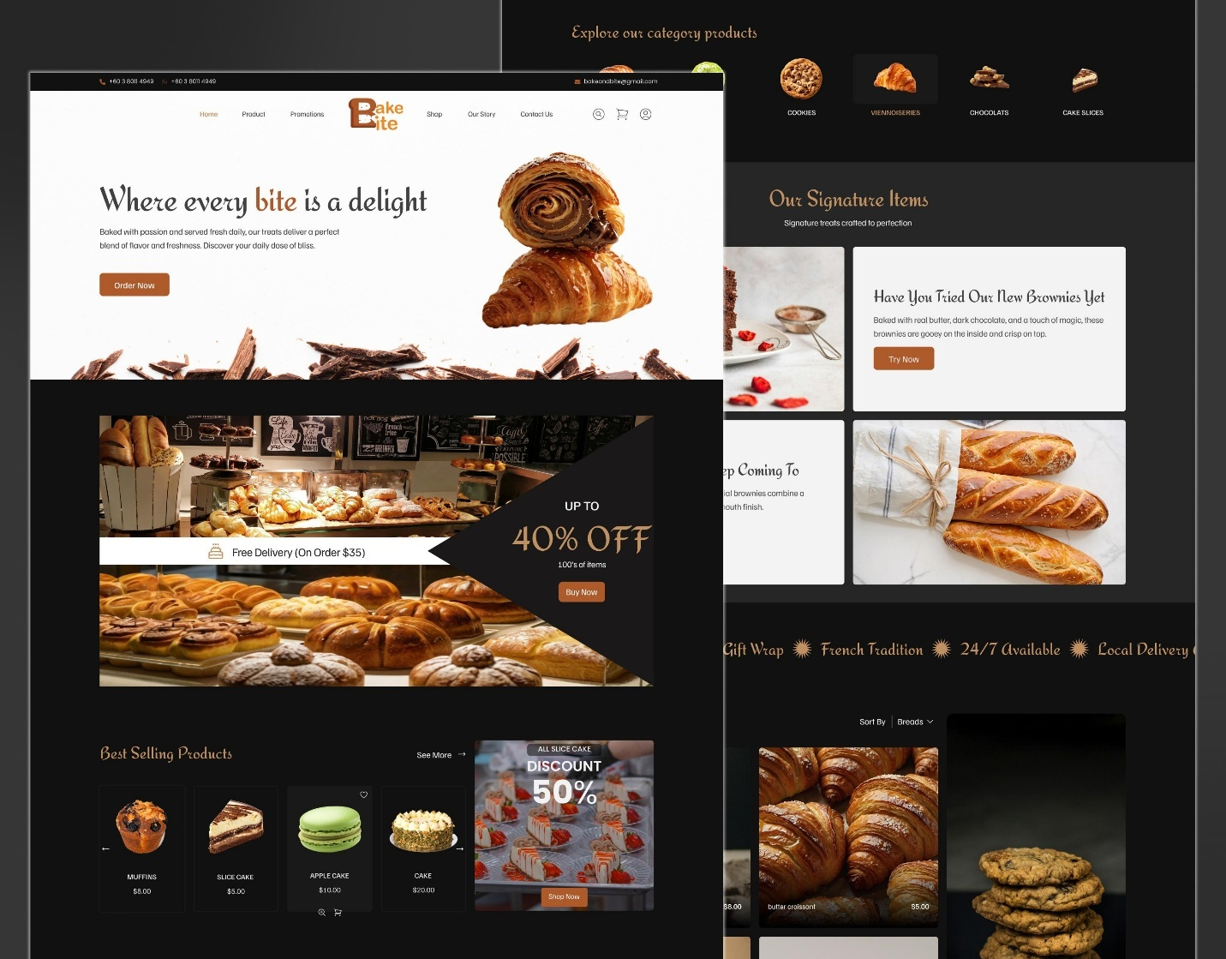
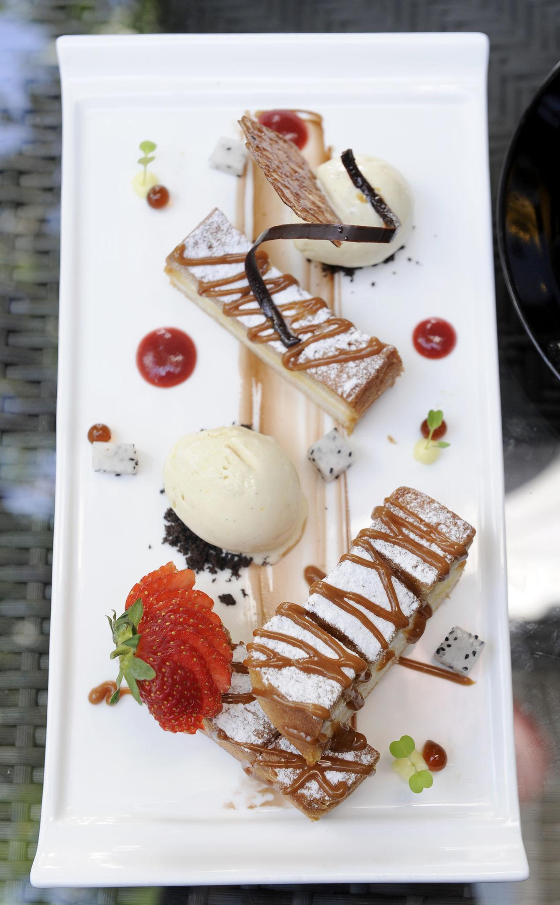
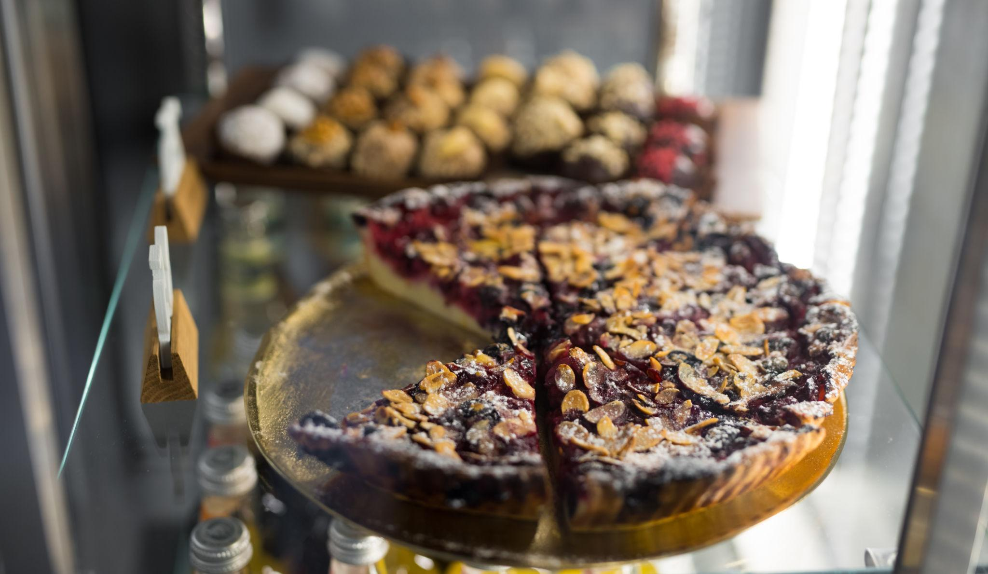
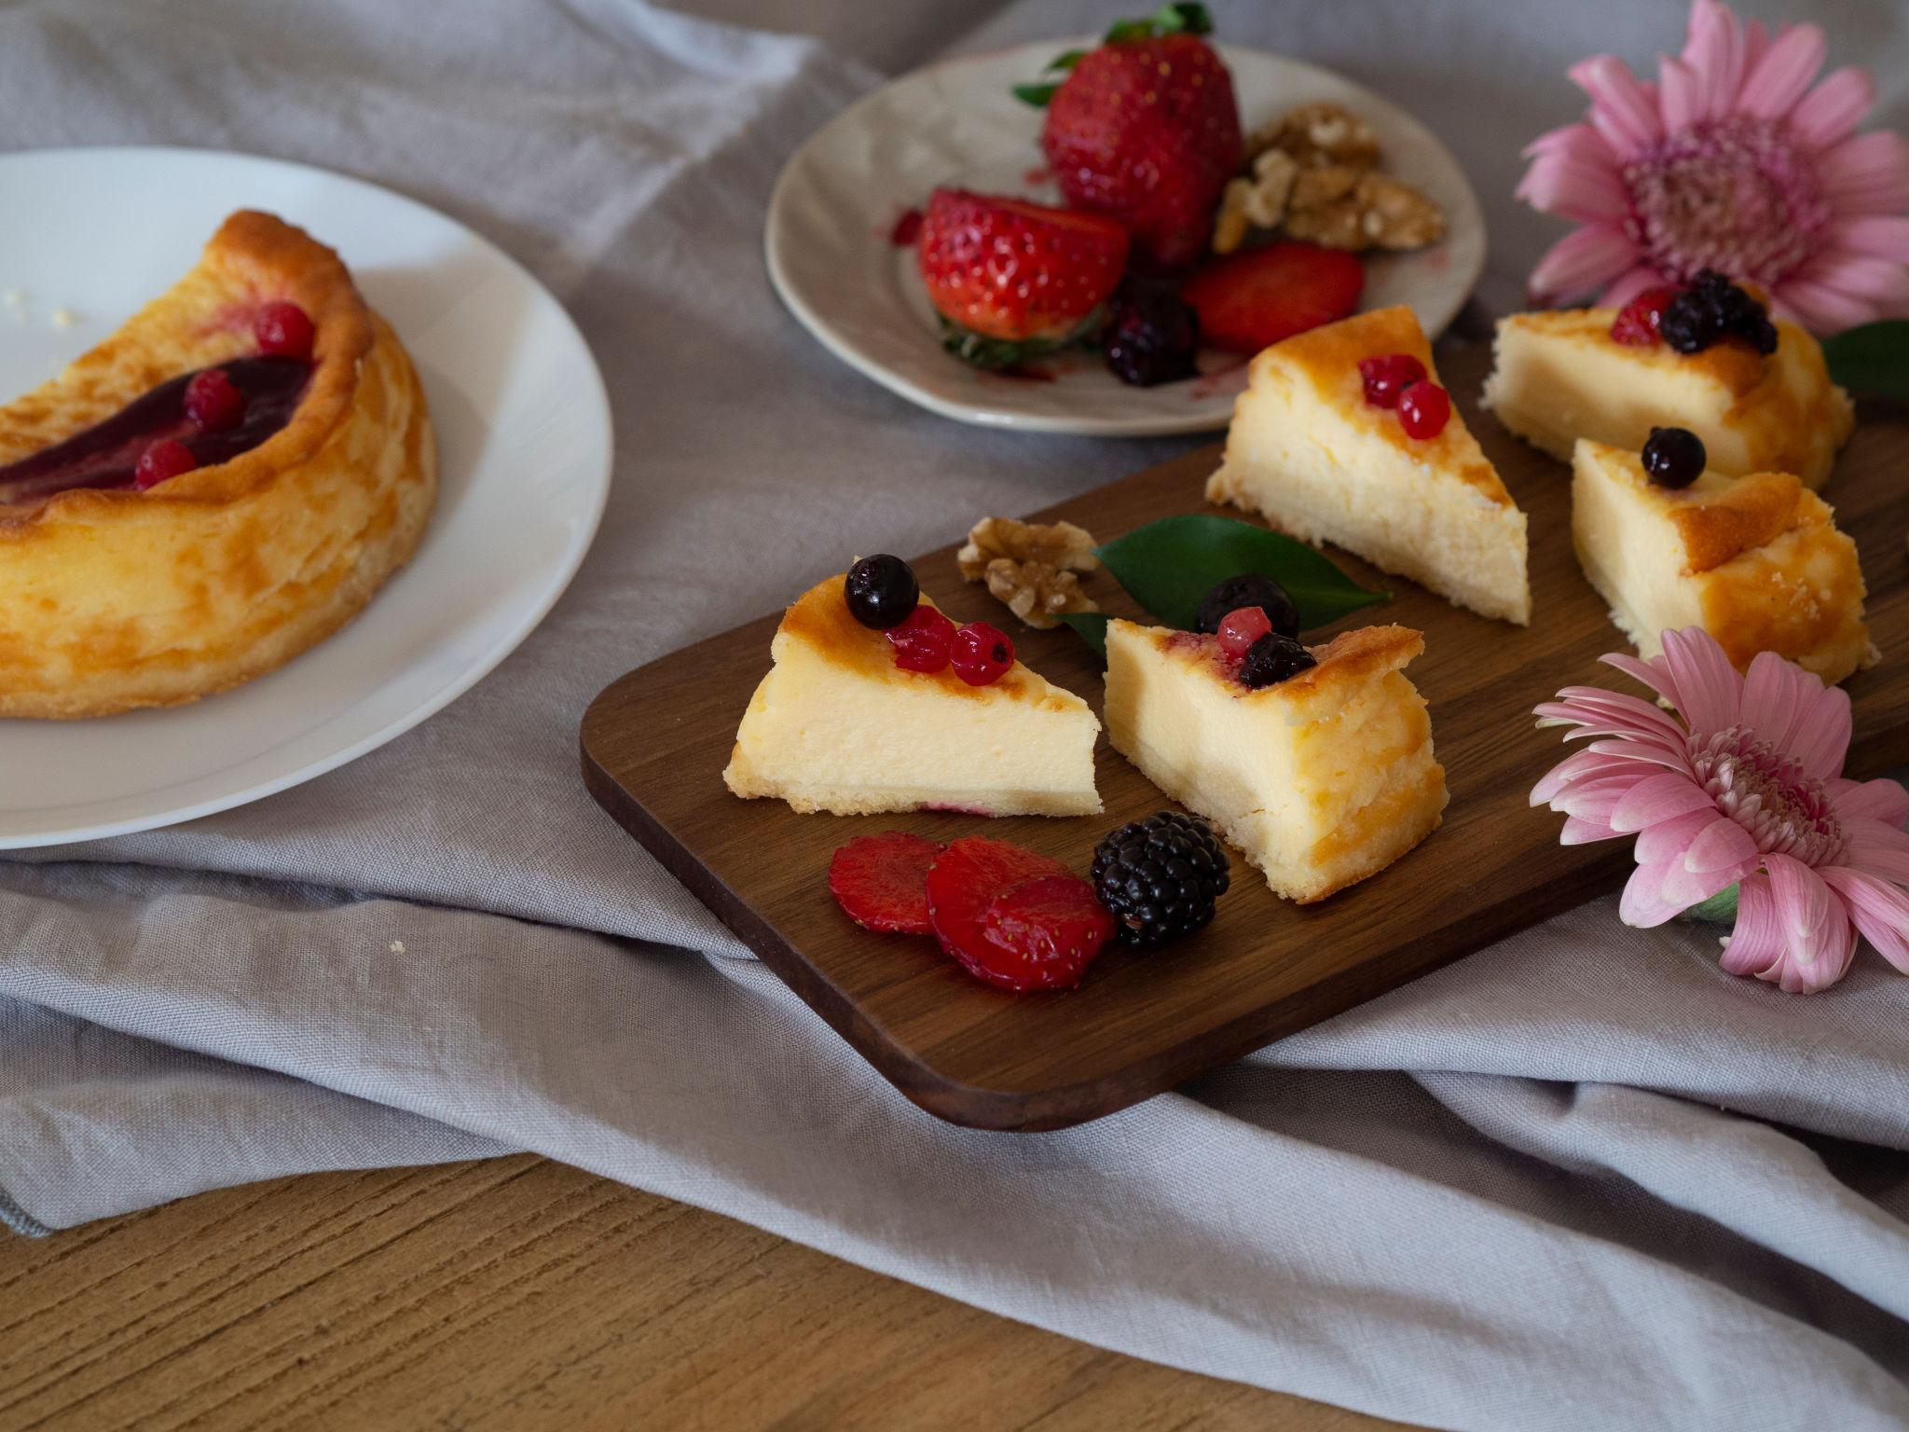
Featured:
- Cheesecake of the Day
- Cinnamon Rolls
- Seasonal Desserts
Hover effect:
- Sauce pours slowly
- Steam rises
- Plate rotates

Color Theme
Based on Urban Cafe's branding:

Primary
- Coffee Brown #4A2C2A
- Cream #F8F3ED

Accent
- Gold #D4A15A
- Sage Green #7A9E7E

Background
- Dark Espresso #1A1412

Technology Stack
For a truly premium 3D experience:
- HTML5
- CSS3
- JavaScript
- Three.js
- React
- GSAP animations
- Blender (3D food models)
This would give Urban Cafe a website that feels less like a menu and more like walking into the café itself, with today's specials dynamically changing every morning while the "Urban Legends" remain permanently showcased as signature dishes.

